**A PROJECT REPORT**

**ON**

**“Soletude – An eCommerce Business Startup for Footwears”**

**Submitted To: Conducted By:**

Ms. Ramsha Khalid Abdullah Wasif(2025-CS-198)

**Course Instructor Name:** Faizan Ahmed(2025-CS-194)

Usman Ashfaq M. M. Shoaib(2025-CS-201)

Amama Ishaq(2025-CS-209)

Dua Javaid(2025-CS-211)

**Date:** 11/10/2025

Table of Contents

**Executive Summary** 2

**Project Objectives and Scope** 3

**Site Structure and Navigation** 4

**Design Choices** 5

**Assets Used** 6

**How to Run / Publish the Website** 6

**Reflection (Learning & Improvements)** 7

**Live Website URL** 7

# **Executive Summary**

This project presents the design and development of a professional website for **Soletude**, a footwear business start-up aimed at delivering premium-quality and stylish footwear. The website serves as a central digital platform to communicate the brand’s identity, showcase products and provide essential business information to potential customers.

Developed using semantic HTML and external CSS, the project emphasizes a layout, clean navigation and modern design principles. Supporting documentation, including this Word report, an Excel data workbook and presentation slides, ensures consistency, clarity and professional project delivery.

# **Project Objectives and Scope**

**Objectives**

The primary objectives of this project are:

* To design and publish a professional website for a footwear start-up brand.
* To establish a strong digital identity for **Soletude.**
* To apply HTML, CSS and website design techniques in a real-world context.
* To demonstrate proper project documentation and version control practices.
* To integrate business presentation with technical web development skills.

**Project Scope**

The scope of this project includes:

* A static business website developed using HTML and CSS.
* Multiple webpages including Home, About, Featured products, Trending products, Menu bar, Contact, Various categories, Account, Cart and Subscription Bar to stay connected.
* Focus on fronted design and user experience.
* Suitable for a small to medium footwear start-up.
* The project can be expanded in future to include e-commerce functionality and backend systems.
* The product gallery is featured with the ratings of each product for customer satisfaction and trustability.

# **Site Structure and Navigation**

The website is structured to ensure clarity, accessibility and ease of navigation for users.

**Website Pages**

* **Home Page**

Introduces the Soletude brand, highlights featured products and trending footwear articles, presents the brand’s tagline and identity, showcases menu on top with brand logo, categories along with their sub-categories in drop down, cart icon to access the cart page, account icon to access customer’s account login and sign-up and brand’s about in the footer that showcases subscription bar, contact info and customer service information.

* **Cart Page**

Displays shopping review along with subtotal, shipping fee, products details and checkout bar.

* **Account Page**

This page showcases and interface where user can easily sign up to their new customer account or can login if they already have an account.

* **Products / Services Page**

Displays footwear categories that include New Arrivals (with sub categories of winters, limited edition and premium designs), Men (with sub categories sneakers, sports shoes, formal shoes and boots), Women (with sub categories heels, party wear, sneakers and sandals), Kids (with sub categories school shoes, joggers and crocs), Wedding Classics (with sub categories bridal heels and groom shoes), and accessories (i.e. shoe polish, shiner and socks).

* **Gallery / Samples Page**

Showcases high quality images of footwear products along with their price and ratings for customer satisfaction.

**Navigation Design**

A consistent navigation bar is used to allow users to move easily between sections, improving overall user experience.

# **Design Choices**

**Typography**

A clean, modern serif font i.e. **Poppins** is used throughout the websites to ensure readability and a professional appearance.

**Color Scheme**

The website uses a minimal color palette consisting of:

* Black and White for a premium and elegant look with a little touch of golden-yellow to make it look more attractive.
* Neutral accent tones to complement footwear aesthetics.

This color section reflects sophistication, durability and trust-key qualities for a footwear brand.

**Layout of the website**

* Semantic HTML structure.
* External CSS for styling consistency.
* Flexbox and Grid layouts along with padding and margins for major sections.
* Proper scaling and alignment to maintain visual hierarchy.
* All the products images placed with fixed dimensions to make an overall neat look.
* Dropdown effect used in menu to access all the categories and sub categories in a user-friendly way.
* An overall white background is used to make the website look elegant.

# **Assets Used**

**Images**

* Footwear products images.
* Brand logo of Soletude.
* Cart Icon
* Account / profile icon.

All images are either self-created or sourced from royalty-free platforms and are used strictly for educational purposes.

**Data Sources**

* Product names, categories and pricing data were created specifically for this project.
* Business content is original and aligned with the start-up concept.

# **How to Run / Publish the Website**

To access and run the website:

1. Download the project files from the GitHub repository.
2. Open the index.html file in any modern web browser.
3. Ensure all the CSS files are properly linked.
4. The website can be published online using GitHub pages for live preview.

# **Reflection (Learning & Improvements)**

**Learning Outcomes**

This project provided valuable experience in transforming a business idea into a functional digital product. It strengthened understanding of HTML semantics, CSS styling, designing and layouts and professional documentations. Additionally, it enhanced skills related to teamwork, planning and presenting a business concept in structured and professional manner.

**Future Improvements**

* Integration of an online shopping cart.
* Backend database and user authentication.
* To create a fully responsive website.
* Online payment gateway.
* Customer reviews and feedback system.
* Improved accessibility features.

# **Live Website URL**

The LIVE website can be accessed by this URL:

**CLICK HERE**

# **EXCEL SCREENSHOTS**

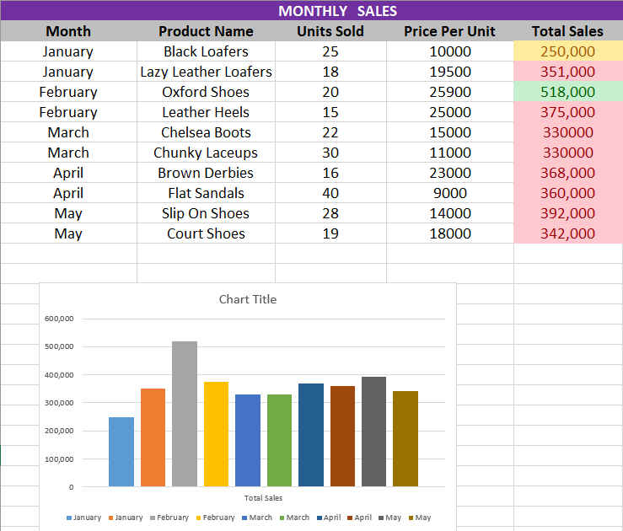

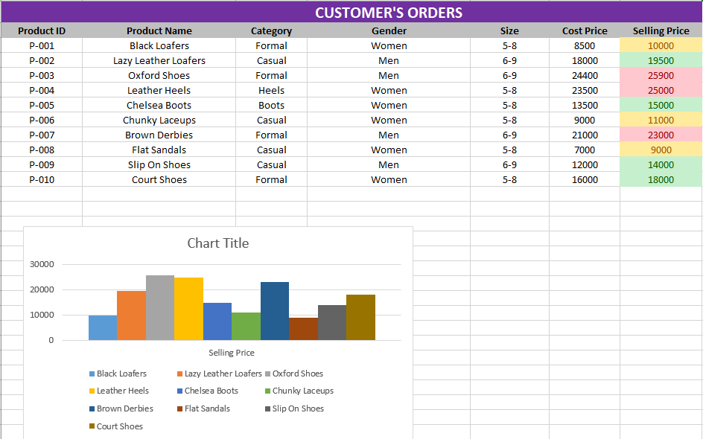

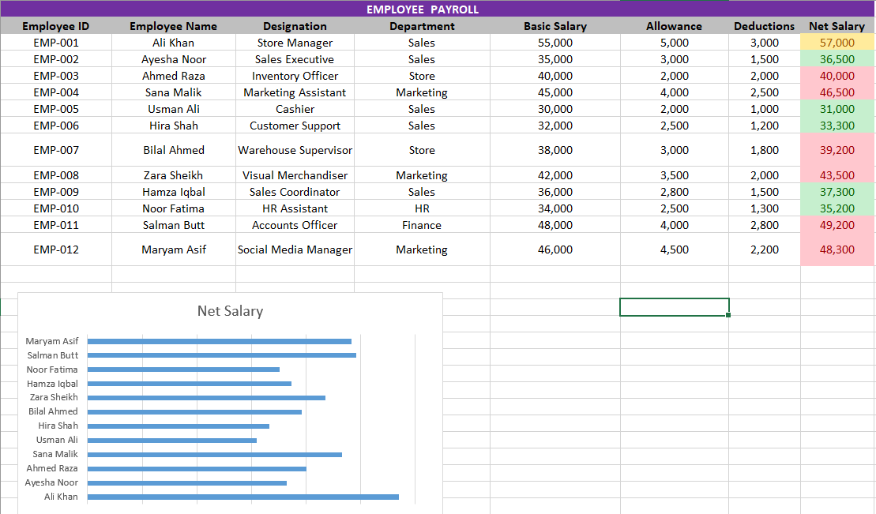

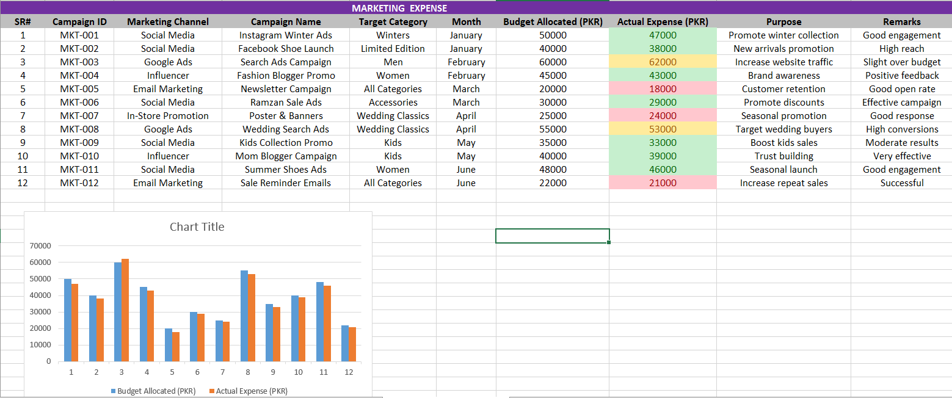

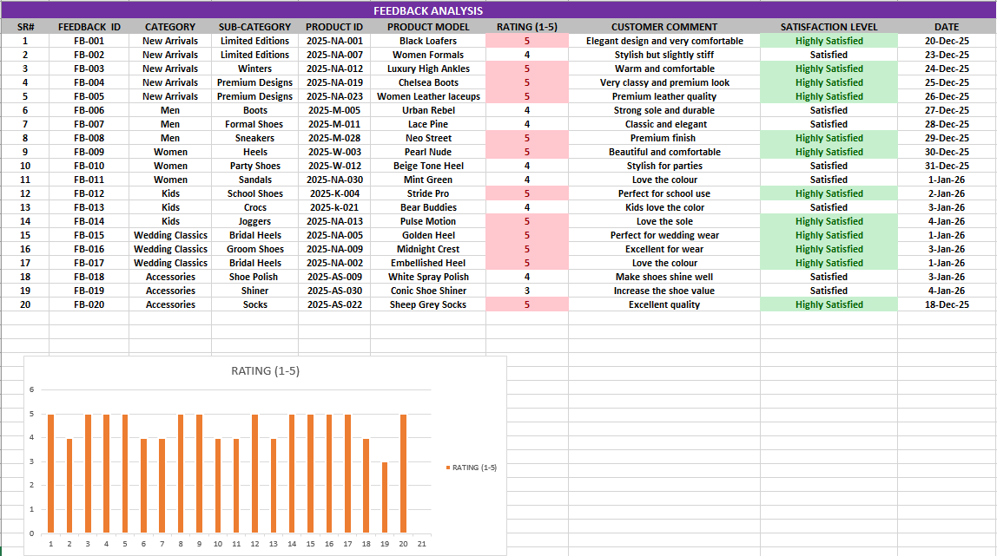

**POWERPOINT SCREENSHOTS**

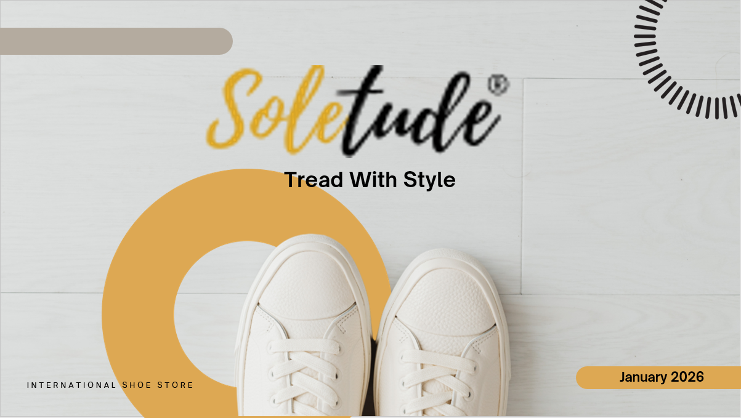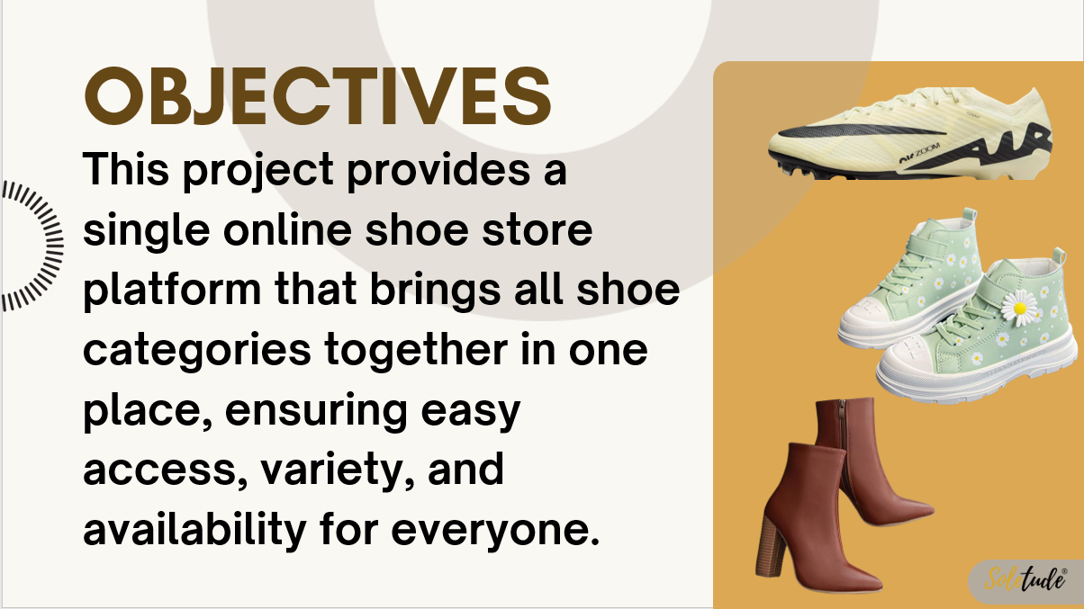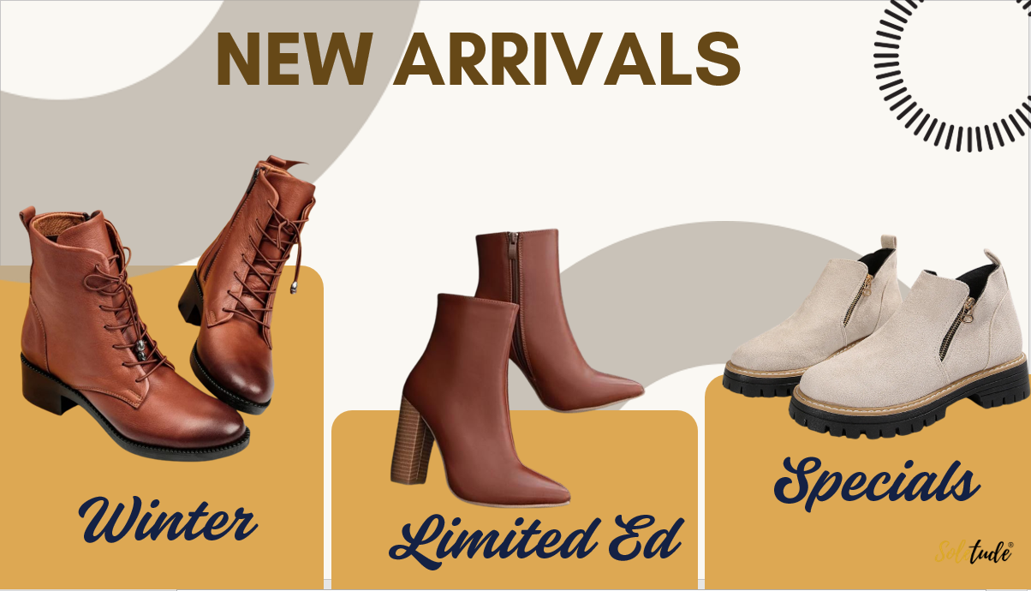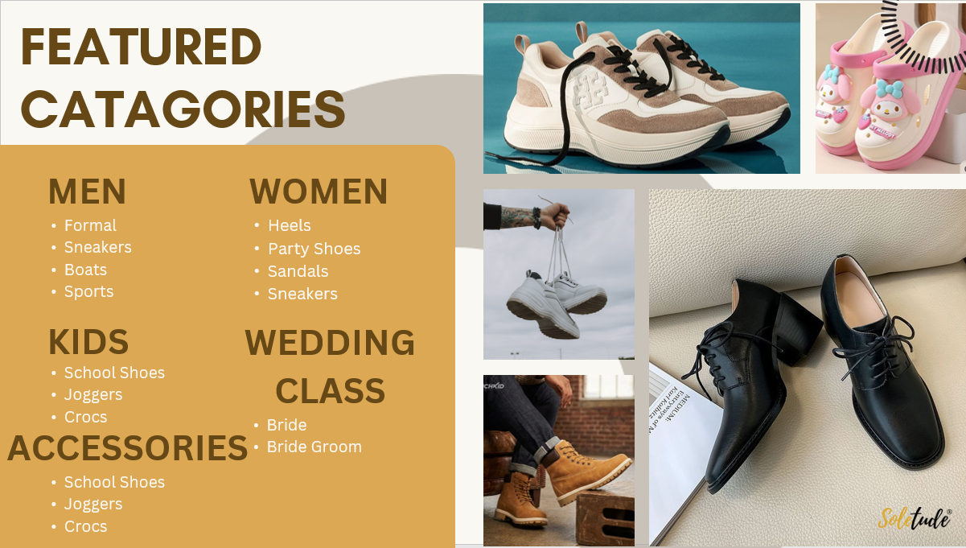

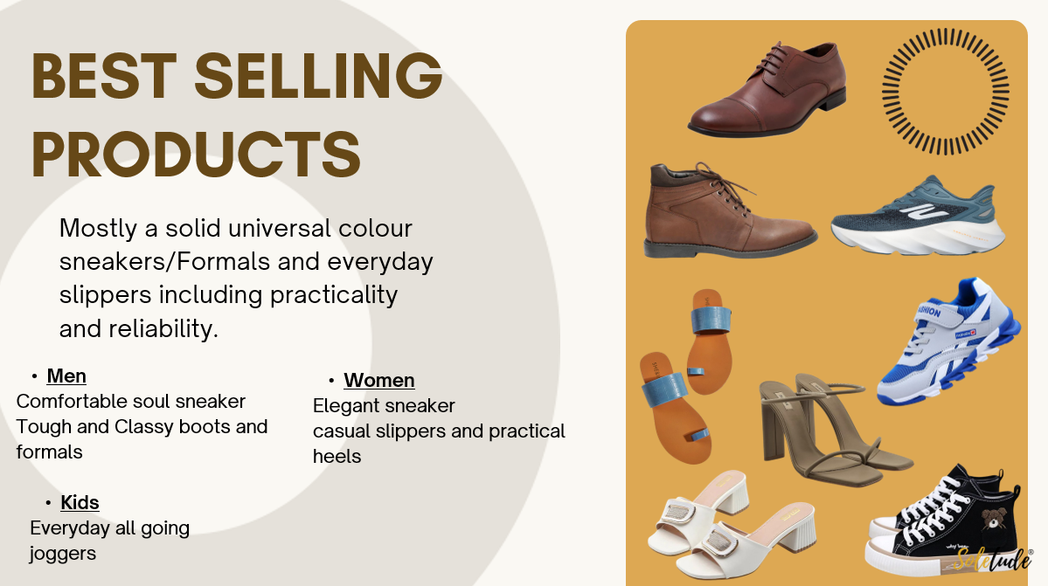

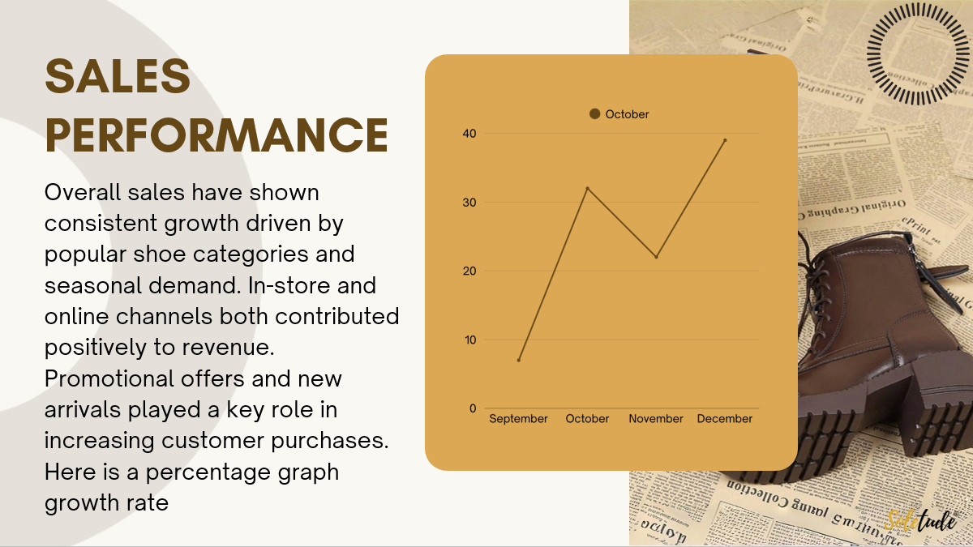

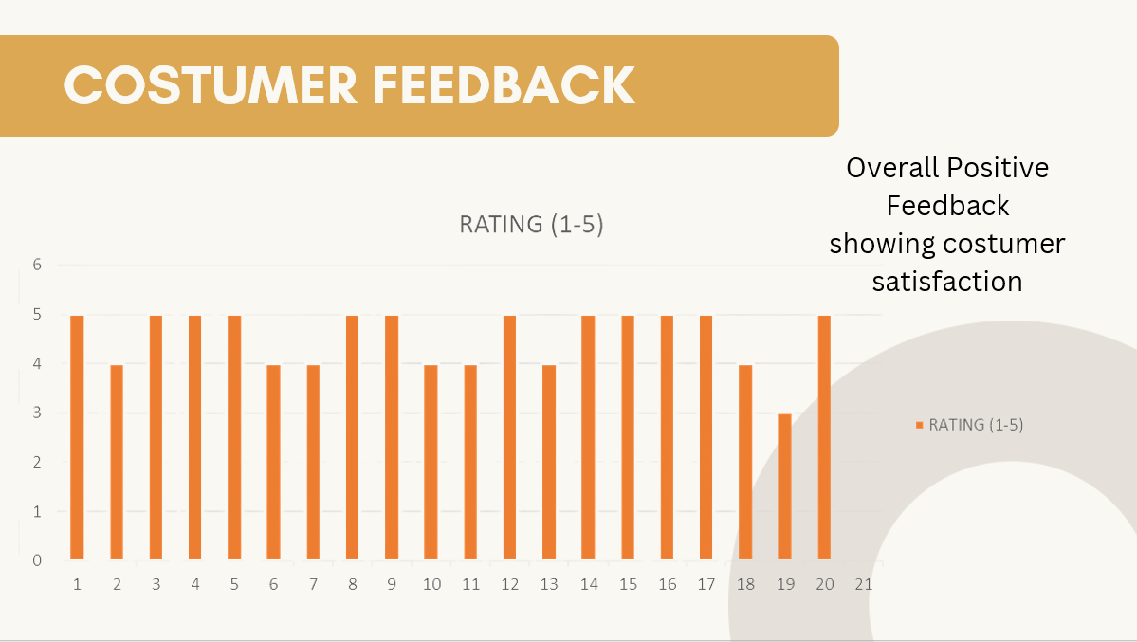

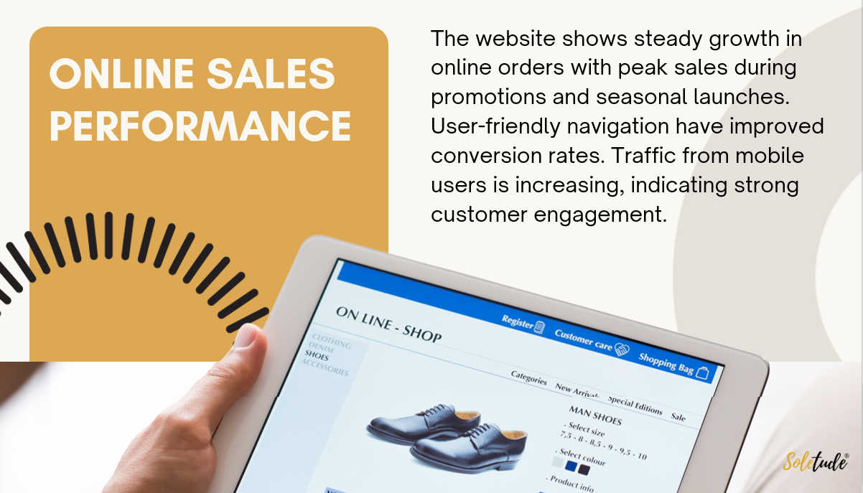

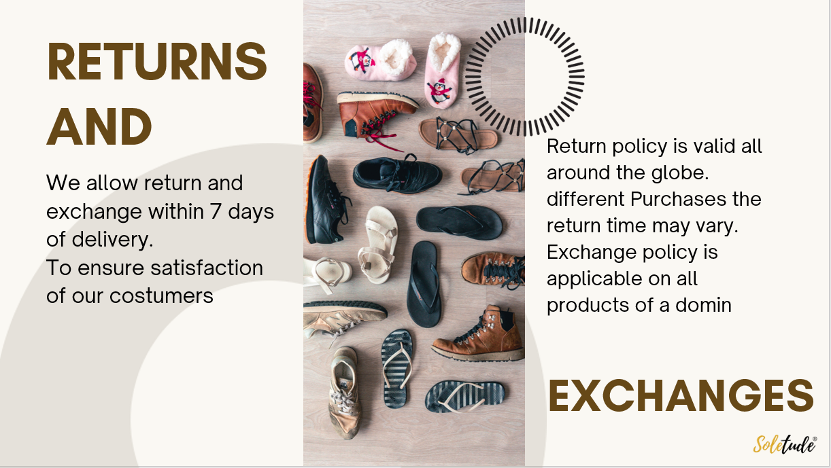

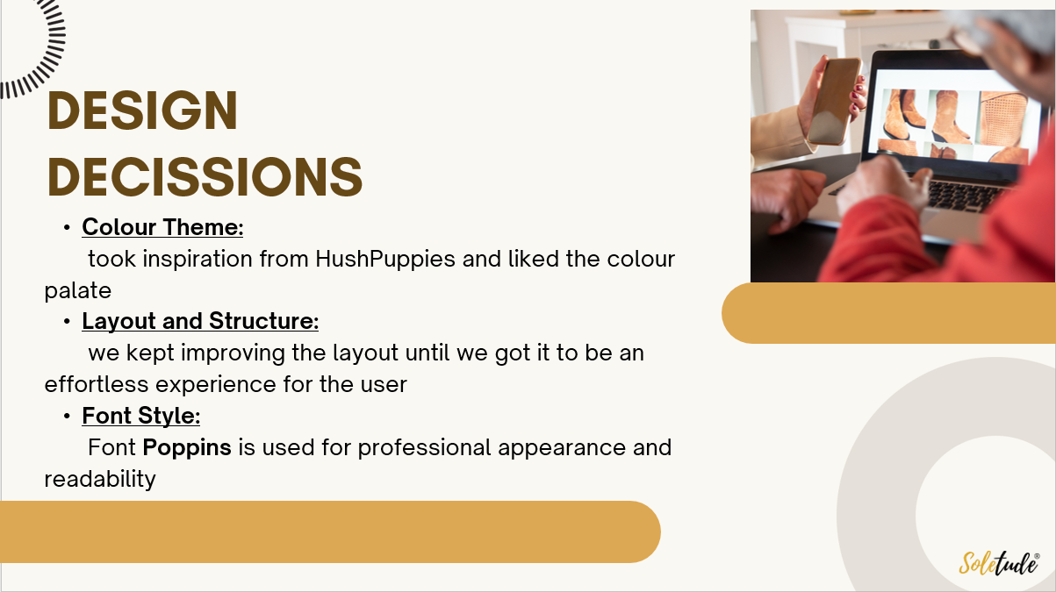

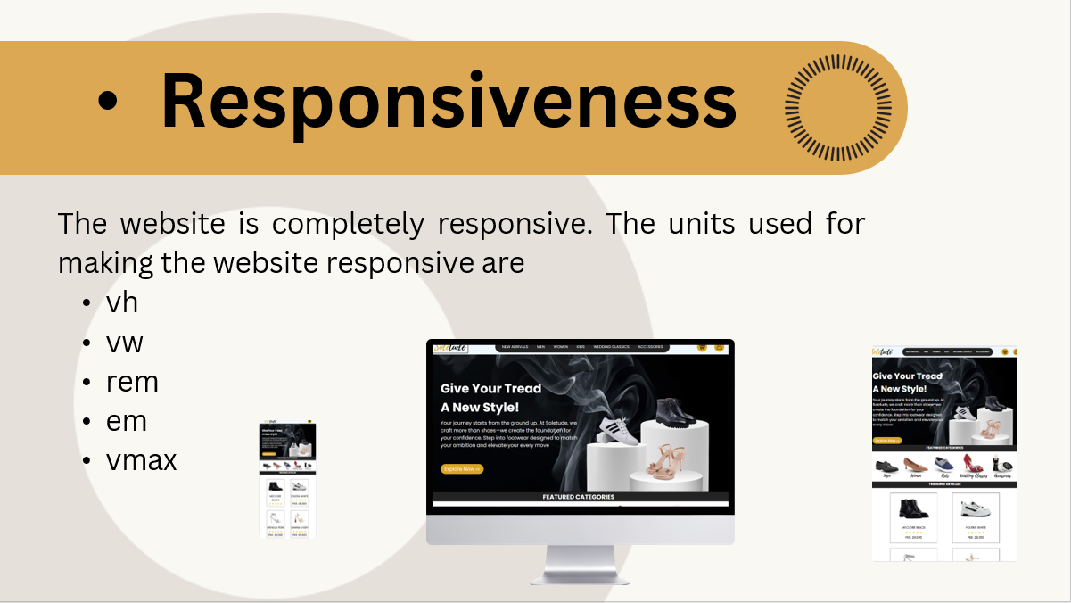

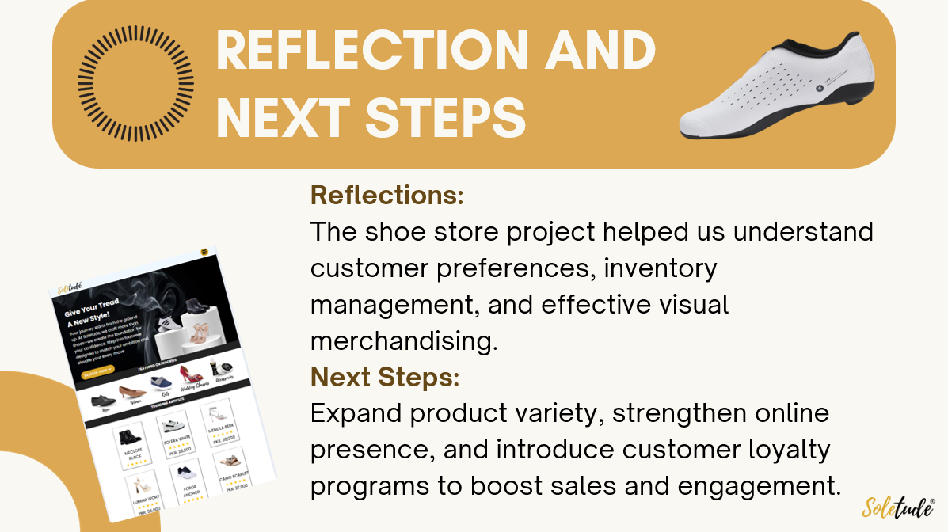

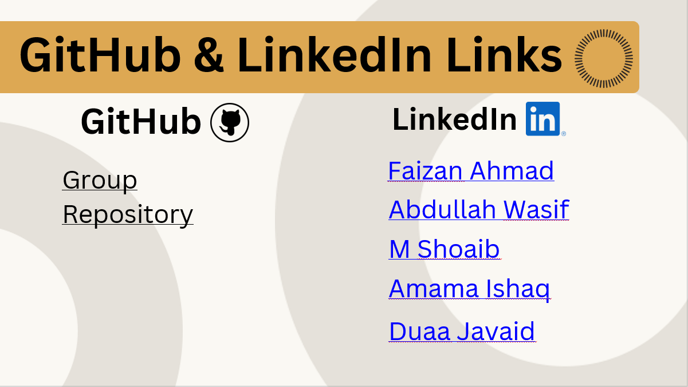

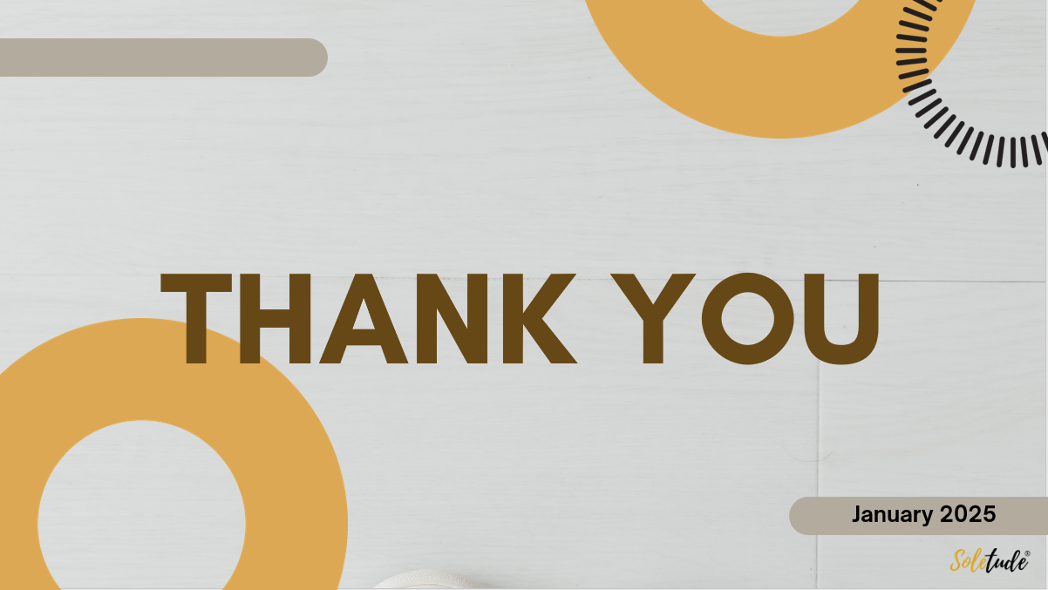

# **Conclusion**

In conclusion, our team selected web development as the core service for our business startup, focusing on building a strong digital presence for the footwear brand **Soletude.** Through this project, we combined creativity, functionality and user-centered design to reflect the brand’s identity and premium appeal. This initiative not only strengthens soletude’s online visibility but also demonstrates our team’s ability to deliver modern, scalable and effective web solutions for emerging brands.